**Wheel Designs**

Research was conducted on non-pneumatic wheels to come up with some wheel designs.

Two support structures were settled on: spokes and honeycomb. These were based off a few papers.

<https://www.researchgate.net/publication/371250020_Design_properties_and_applications_of_non-pneumatic_tires_A_review>

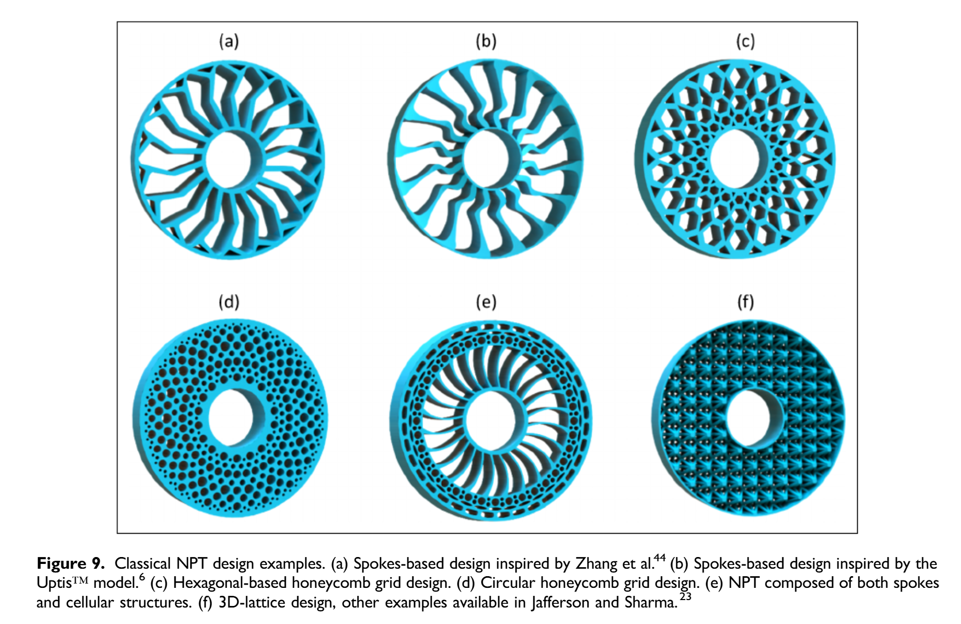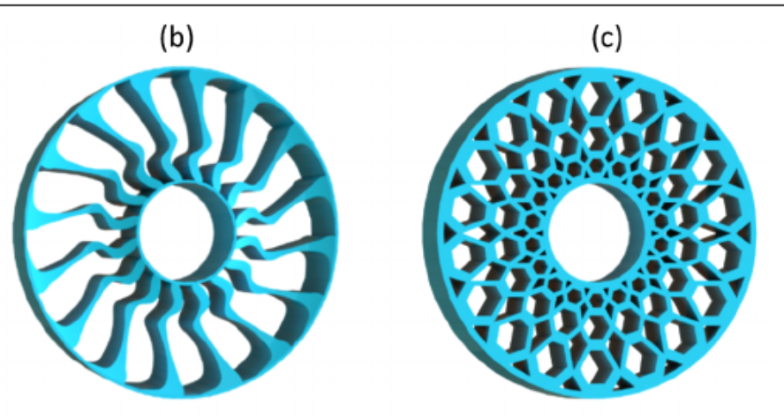

<https://www.researchgate.net/publication/379923695_Development_and_Analysis_of_Additively_Manufactured_Non-Pneumatic_Tires_for_Mars_Rover>

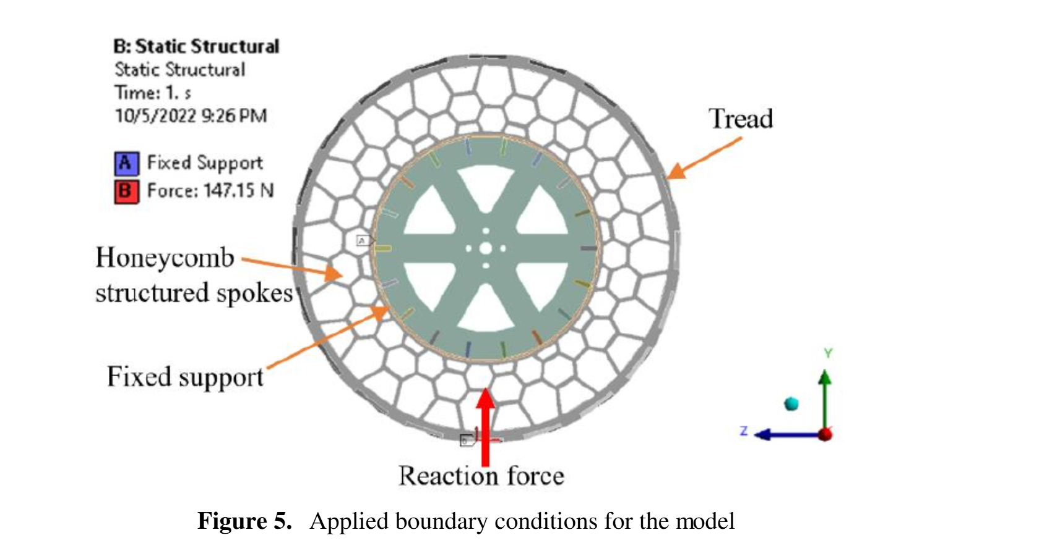

Three tread patterns were settled on: chevrons, straight bars, and knobs. These designs were based off the curiosity rover, the perseverance rover, and dirt bike tires.

<https://science.nasa.gov/mission/mars-2020-perseverance/rover-components/>

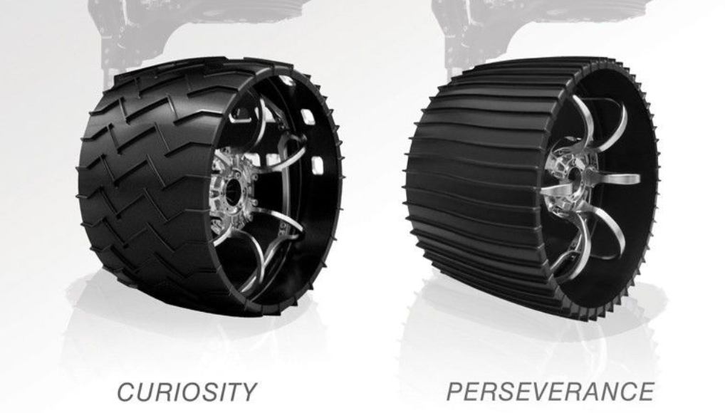

<https://www.dirtbikes.com/dunlop-dirt-bike-tires-what-to-look-for/#:~:text=Described%20as%20Dunlop's%20most%20technologically,and%20maintain%20a%20straighter%20line>.

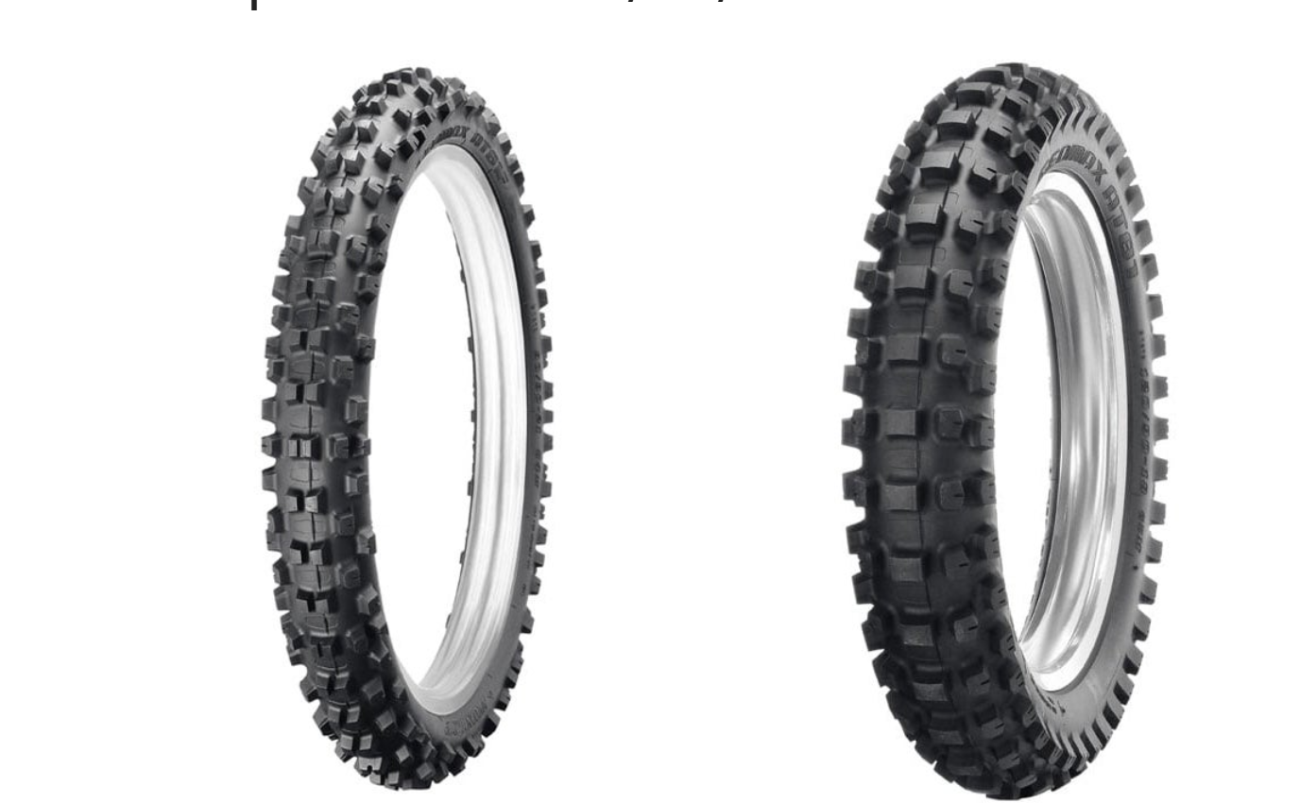

6-wheel variations were made, combining these 3 treads and 2 support structures.

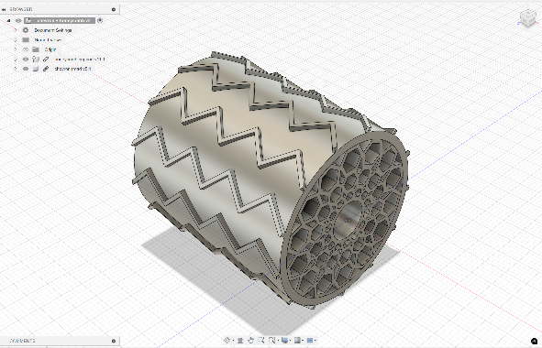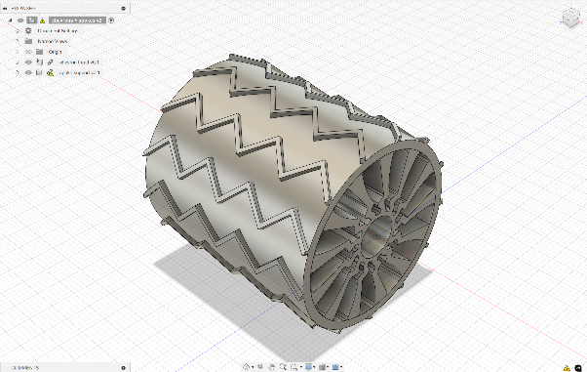

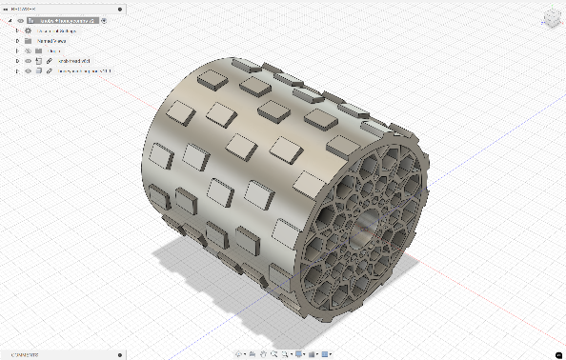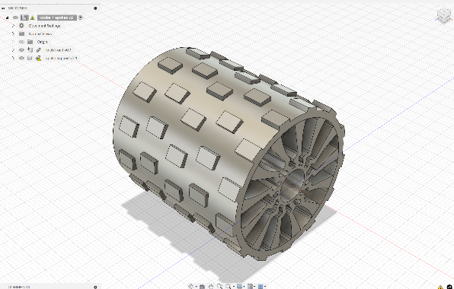

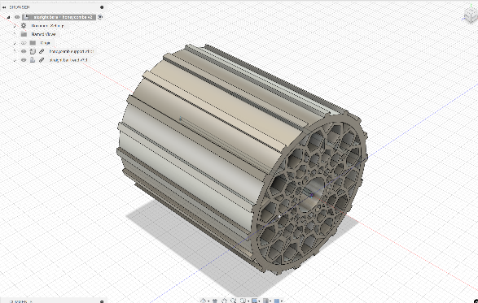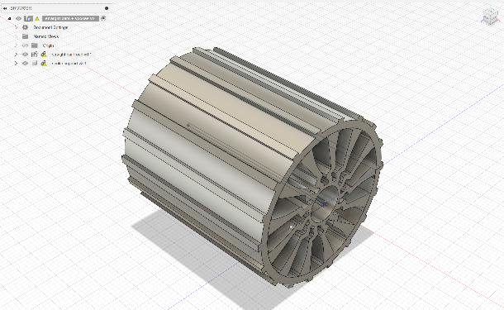

An initial FEA analysis was conducted, and the factor of safety was unnecessarily high, so I redesigned the support structures to remove mass. Rather than being one solid extrusion, I separated it into 3 distinct segments.

